1. Execute and display the results for the following commands in Kali Linux Operating
Systems:
rm command
users command
tree command
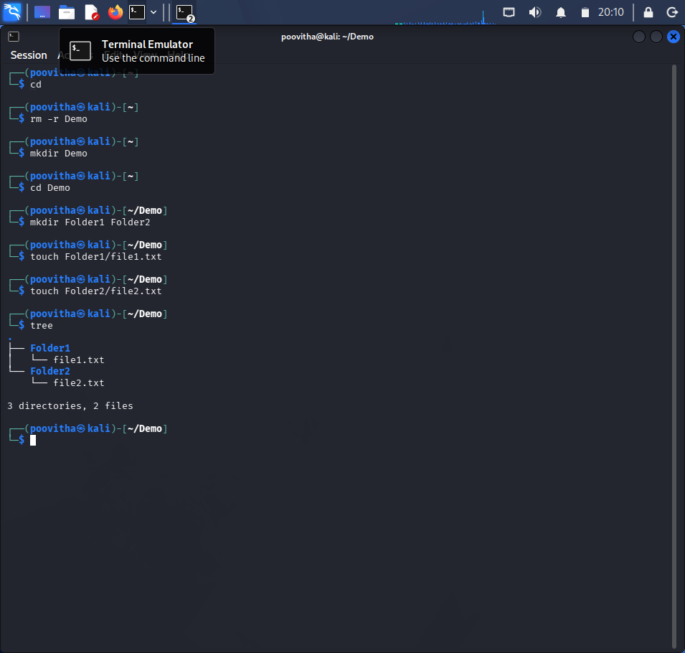
2. Execute and display the results for the following commands in Kali Linux Operating
Systems:

less command
more command
vi command
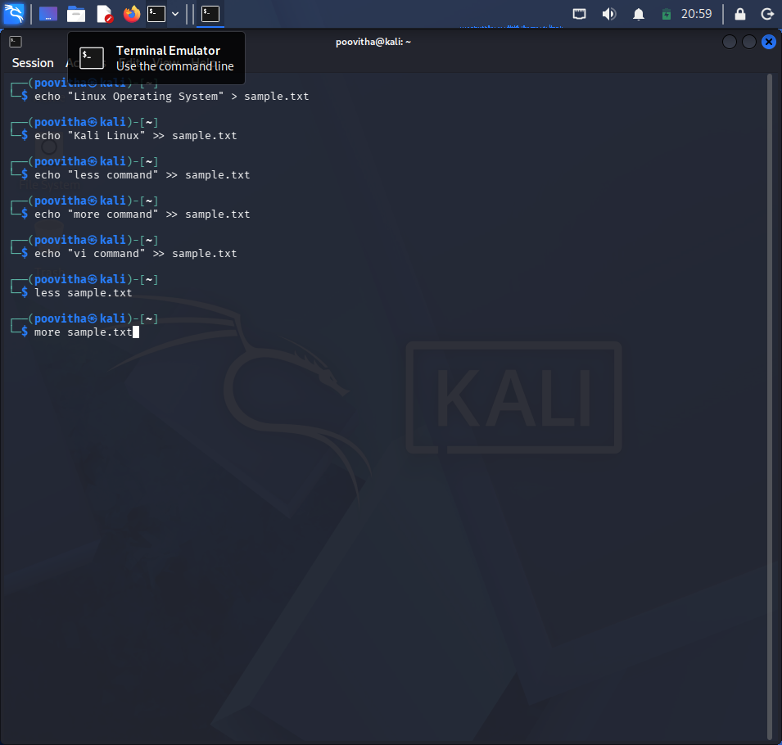
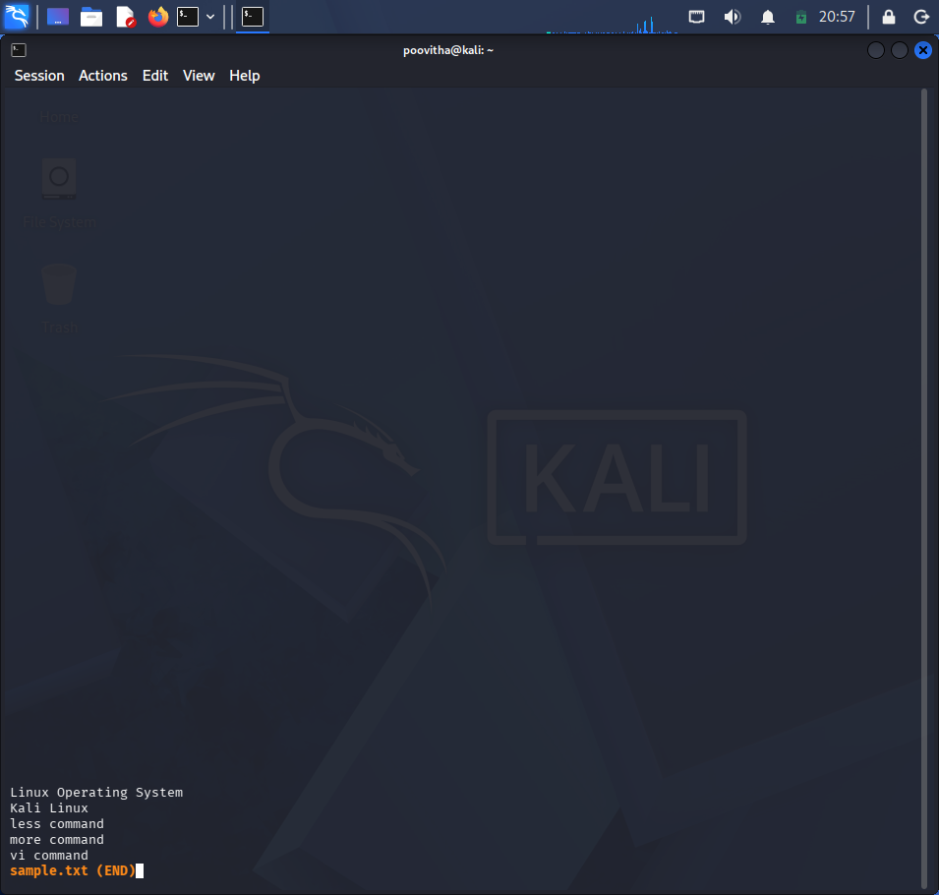
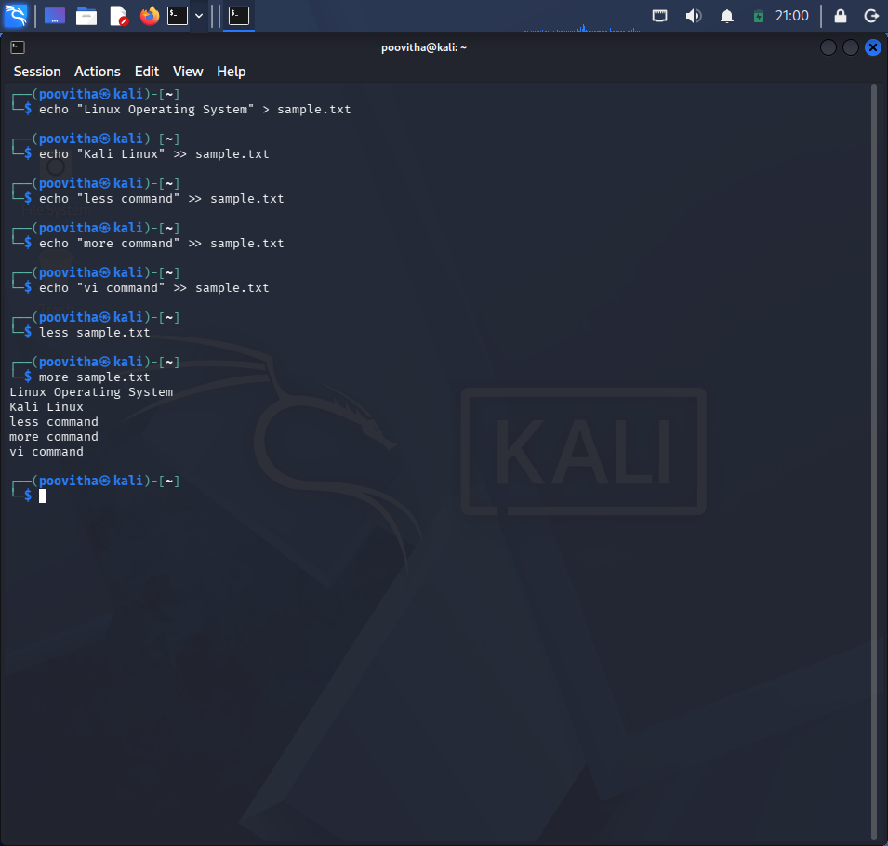
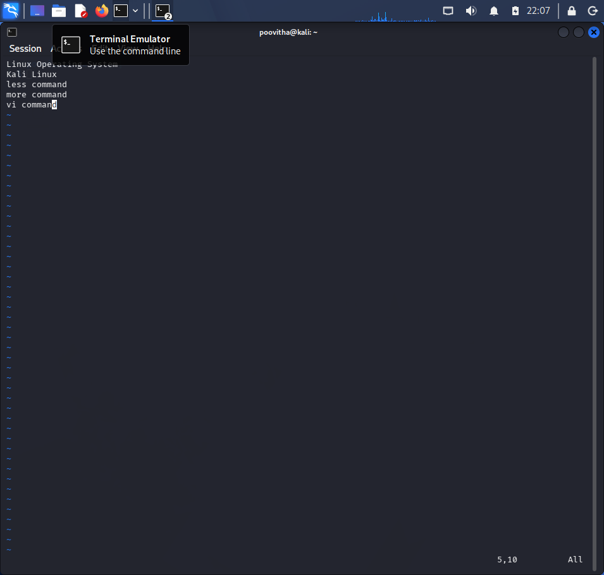
3. Execute and display the results for the following commands in Kali Linux Operating
Systems:
Tree
Head
Tail
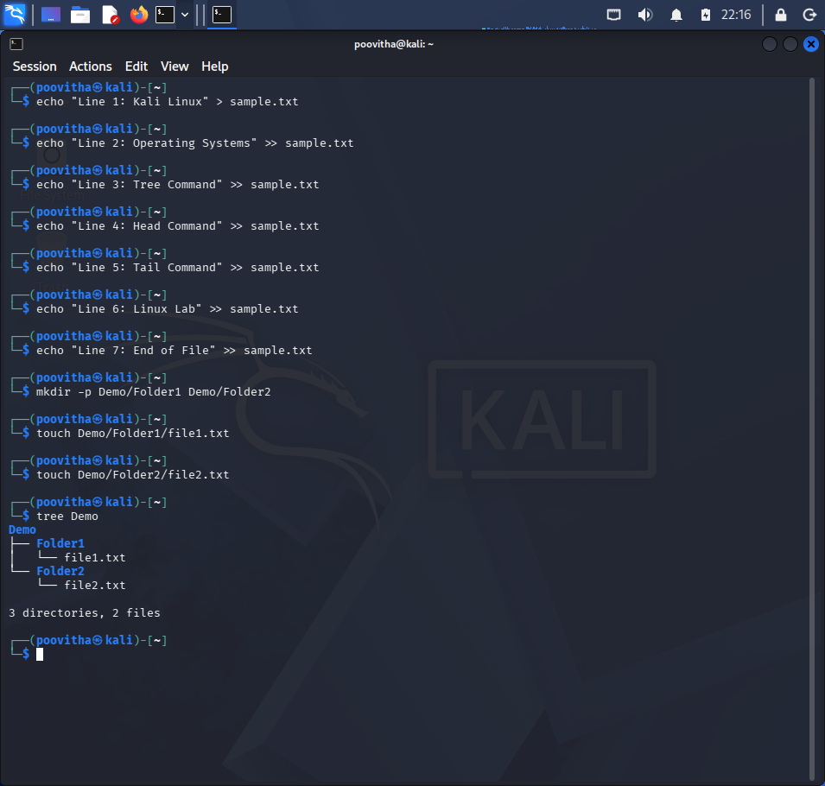

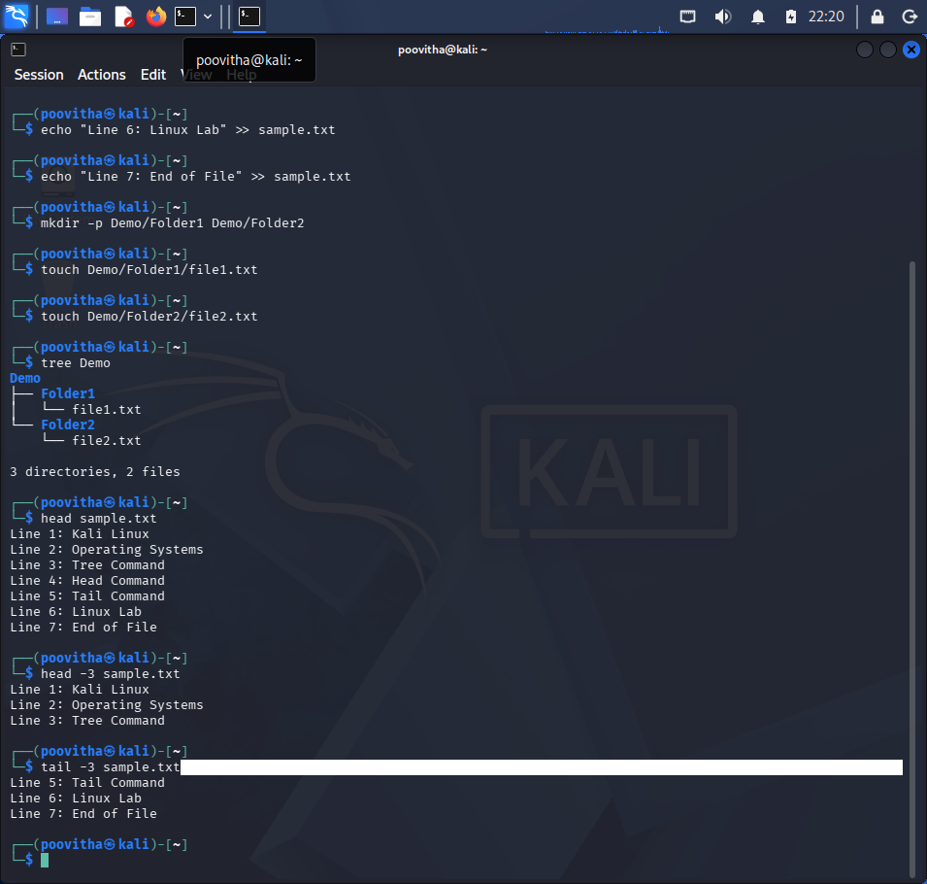
4. Execute and display the results for the following commands in Kali Linux Operating
Systems:
i) Ls
ii) Cat
iii) Mkdir

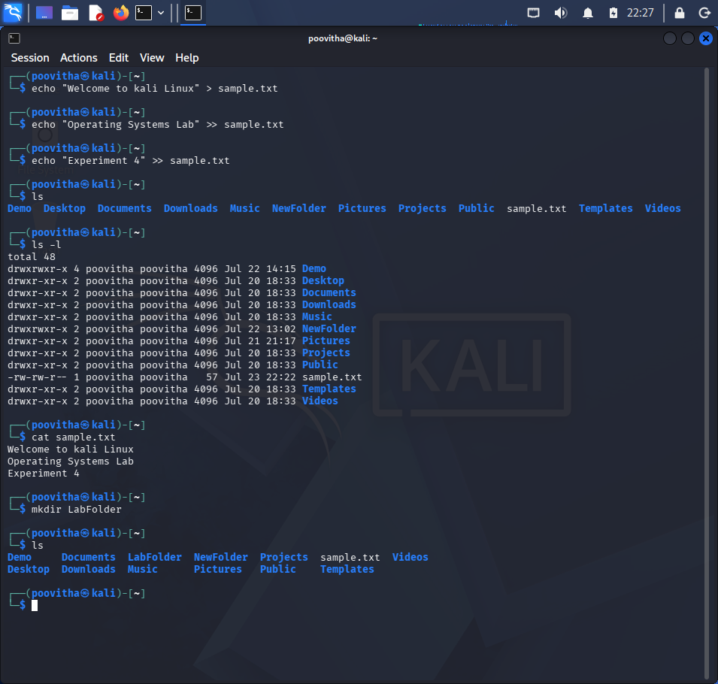
5. Execute and display the results for the following commands in Kali Linux Operating
Systems:
i) Uptime
ii) Date
iii) Mv
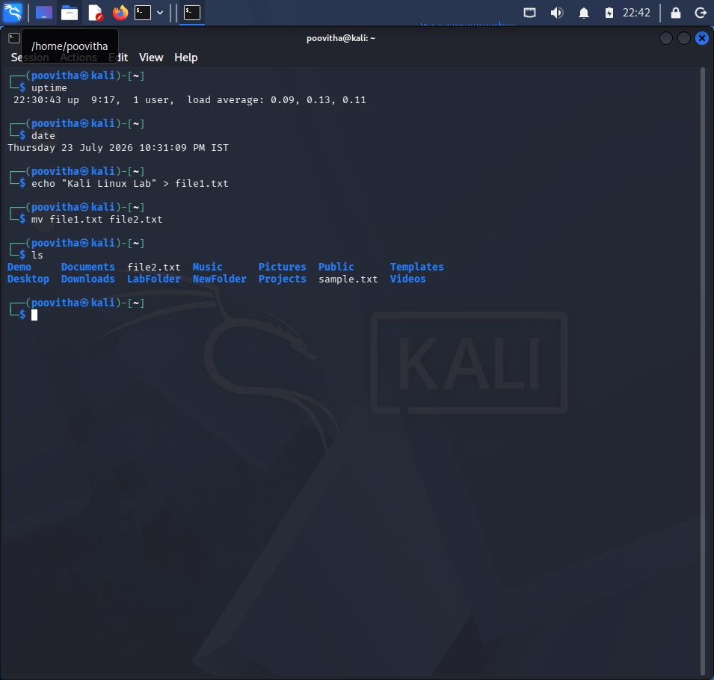
6. Execute and display the results for the following commands in Kali Linux Operating
Systems:
i) Touch
ii) Pwd
iii) Wget
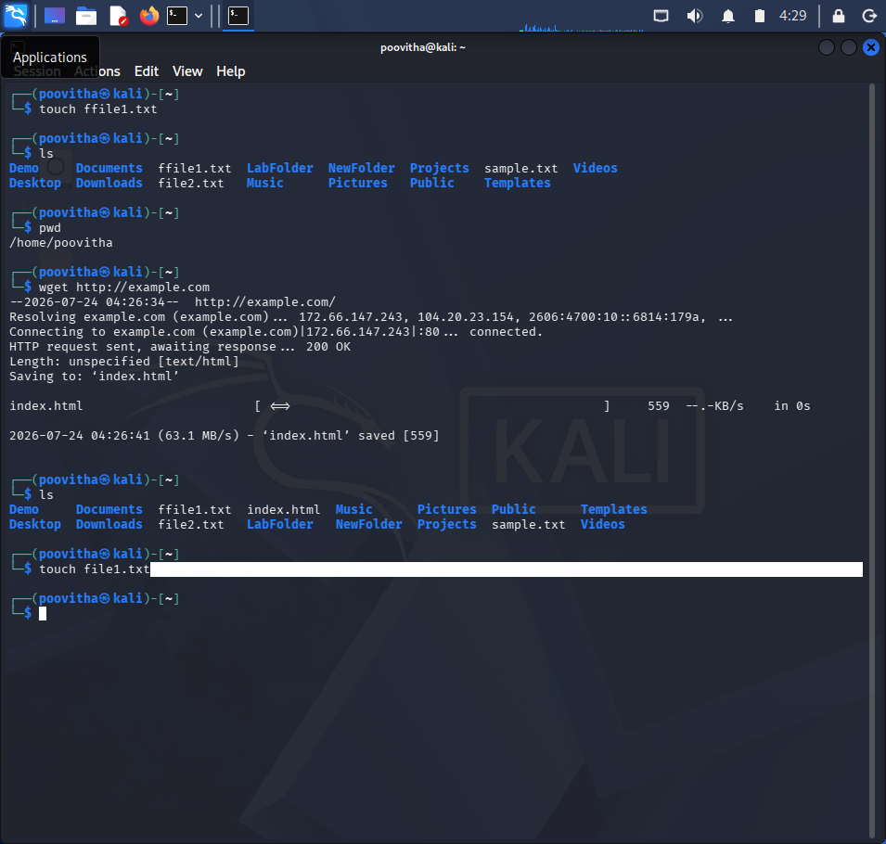
7. Execute and display the results for the following commands in Kali Linux Operating
Systems:
i) Cd
ii) Cp
iii)ls
